Corrections for ISCA ISCA-RJRS-2012-275 final proof
1. The manuscript is correct and there is no need to change, only in minutes symbol it should be ‘ '’ rather than ’. The correction is as follows
Lat-19°10'-19°30'N and Long-84°45'-85°10’E is the correct one- Page 2
2. Figures 1, 2, 4, 5, 11 seem to be compressed from below. We recommend making it compressed from any corner of the JPEG image so that the aspect ratio remains same and looks clear.
Here an example: Original in Proof
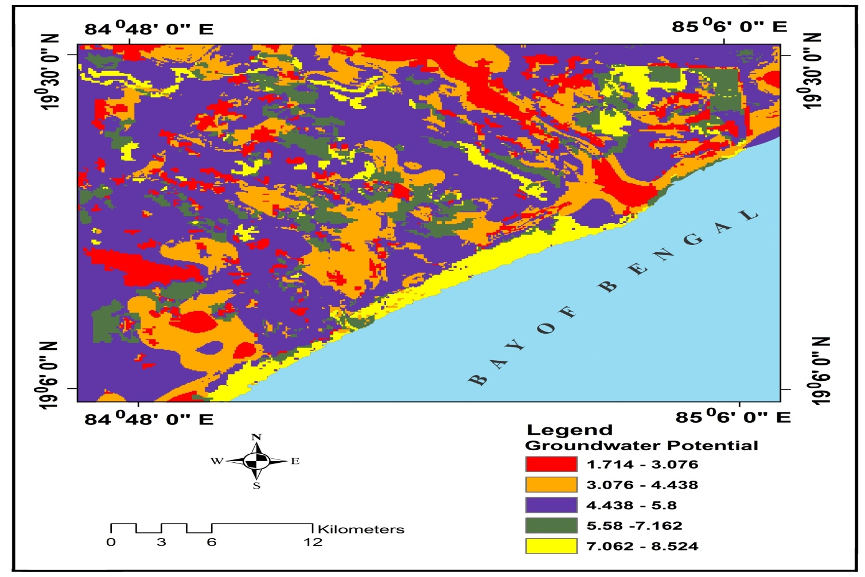

Final after making it smaller:
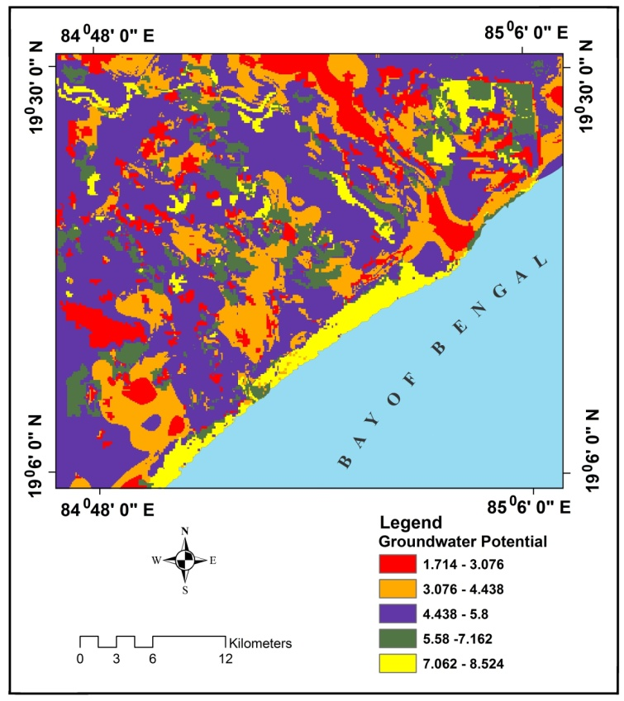
Please make it like this so the map remains in its original form and the features are not compressed from either side. You can choose any corner of the figure and compress it rather from any side of the map.

3. Table 1:
Geomorphology, y is in the second line. We recommend shifting the column line to right so that “y” does not come in the second line.

