Groundwater exploration study using Wenner-Schlumberger electrode array through W-4 2D Resistivity Imaging systems at Mahapallipuram, Chennai, Tamilanadu, India

Antony Ravindran A.¹, and Mohd. Abdul Kadar Prabhu H.²
¹Department of Geology, V.O.Chidambaram College, Manonmaniam Sundaranar University, Thoothukudi, TN, INDIA
²WTS Ltd., Shenzhen, CHINA

Available online at: www.isca.in
Received 17th September 2012, revised 20th September 2012, accepted 24th September 2012

Abstract
Groundwater is a very important component of water resources in nature. Since the demand of groundwater increases with population growth, it is necessary to explore groundwater more intensively. In order to determine the existence of usable groundwater for irrigation and drinking purposes in Mahapalipuram, 2D resistivity imaging technique was utilized. The 2-D resistivity imaging technique utilized the Wenner-Schlumberger electrode array configuration because this array is moderately sensitive to both horizontal and vertical structures. The surveys were carried out using W-4 of WTS Ltd, China. The survey is employed with resistivity meter, multicore cable, multi electrodes with wenner and schlumberger array configuration respectively. The collected resistivity data were interpreted using by Res2DINV original software. Three lines were surveyed for groundwater delineation purpose. The length for each survey lines is around 260 meters. At Mahapallipuram, the survey site shows the existence of groundwater. It is indicated by the resistivity values about 10-100 ohm-m. The maximum depth of investigation survey is 39meters. In general the results show that the subsurface is made up of alluvium and clay and the high resistivity values of more than 1000 ohm-m near the surface is due laterite and the end of the depth can be interpreted as mixture of weathered material or bedrock.

Key words: Groundwater, apparent resistivity, 2D ERI, pseudo section, Chennai.

Introduction
The Mahapallipuram site is a study area and a part of the Chennai out skirts. The study area is located in N 40°69. 92’ and E 13°98. 250’ of Tamil Nadu. Its water supply need is partly met from surface and partly from groundwater. Hence both quantity and quality of groundwater are very important for domestic purpose. But the groundwater quality in study area varies widely from good to moderate. The main aim of the study involves the groundwater investigation using Vertical Electrical sounding and 2D electrical resistivity imaging study in the Mahapallipuram area. The study area is underlain by the geological formations ranging from Archeans to recent. Most of the geological formations are concealed and overlain by the recent alluvium. Few exposures of Archean age are met with the south of Chennai. Most of the surface layer is covered by laterite and calcareous layer with granite are occurred in the study area (figure 1).

Material and Method
The data were collected from the field survey which is stored in the memory of mainframe of W-4. The stored data is transferred using USB cable to PC or Laptop from the equipment. The collected data is processed using the Res2Dinv original software. The topographical corrections were carried out in the survey. This is the most effective technique to get reliable information in the field and gathered resistivity pseudo section.

Topographic survey is carried out in the five chosen landslide zones by using total station. Total station measures the angles (horizontal and vertical) and distances (horizontal distance and slope) from the instrument to corresponding to the survey line. 2D Geo-electrical Resistivity Imaging (Tomography) study has been conducted in Mahapallipuram region.

Using 2D ERI technique, the fault zone, weathered gnessic rock and weathered soil were studied^{1,2,3,4}. The 2D ERI technique is a fast and cost effective technique, which covers both perpendicular and straight changes in the subsurface resistivity⁵⁻⁶. This 2D technique is also applied for characterization of shallow subsurface studies by^{8,7,9,10} (figure 2). The data collection was carried out with the help of electrical resistivity imaging system, multi-core cables, steel electrodes and Res2DINV software.

The image of pseudo section is constructed on the basis of the apparent resistivity data and provides a simple image. It is not representing the true distribution of intrinsic resistivity, rather gives a very approximate picture of the true subsurface resistivity^{5,11-13.} The Gauss-Newton is the popular general geophysical inversion technique¹⁴.

This technique has developed a fast and versatile implementation of the smoothness - constrained least squares inversion. This inversion technique is a powerful and effective means of processing pseudo section by using RES2DINV Ver.3.56 Software, by which the contoured image of true depth and formation resistivity are prepared.

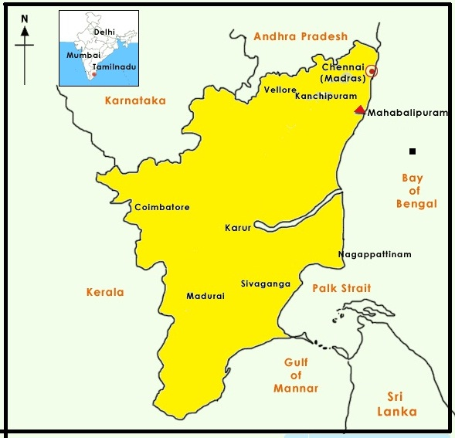
Figure-1
Location map of the study area

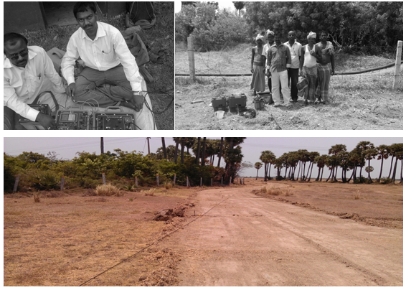
Figure – 2
Field work carried out at Mahapallipuram

Results and Discussion
2D Electrical Resistivity Imaging Pseudosection: The profile 1 trends NW-SE direction to a length of 140m. The upper part of the layer reveal as weathered soil. The inversion resistivity values are obtained from 1 to100 ohm.m in intermediate layer. This indicates freshwater zone at a depth of 10m in the study area while the moderate gneissic profile is located in 100-650 ohm.m. The lower part of the layer represents granite which is evident from the range of high resistivity varying from 5506to 14488 ohm.m respectively (figure 3).

The profile 2: Maximum length of second profile is 140 m and imaging depths of 39.2m. The study reveals the range of resistivity about 120 ohm.m which clearly indicates the ground water zone well recharged from the surrounding area. The intermediate layer 383-595 ohm.m indicates the weathered gnessic rock. The hardrock are identified with high resistivity ranging from 313 to 2043 Ohm.m. (figure 4).

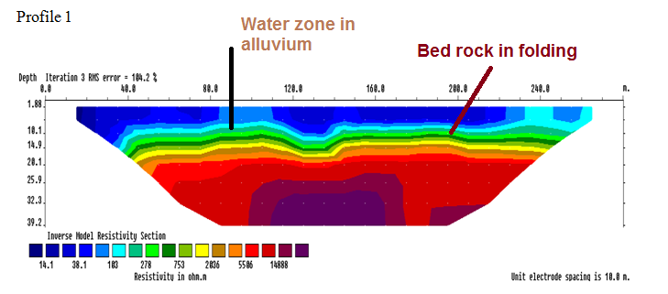
Figure -3
2D electrical resistivity imaging pseudo section depicts the distribution of Groundwater in the field of Mahapallipuram

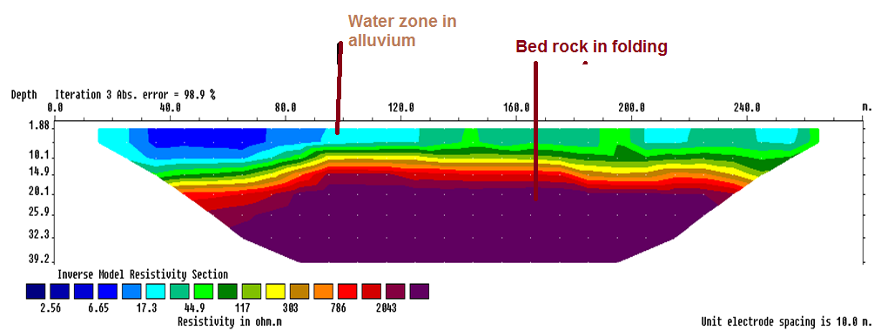
Figure-4
2D electrical resistivity imaging pseudo section depicts the distribution of Ground water in the field of Mahapallipuram.

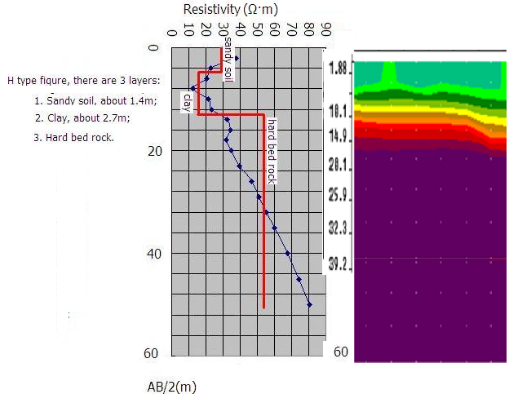
Figure.5
VES data compared with 2D ERI data

The profile 3 (figure 5) The high resistivity zones of bed rock is identified at a depth of 14m to 40m. The low resistivity zone of circled image indicates the groundwater zone in the study area.

Conclusion
The analyses of the pseudo section along the profiles one to three clearly show three broader divisions viz., dry zone; fresh water mixed sandy, clay sands and hard rock enriched soil zone¹⁴⁻¹⁸. The 2D Electrical Resistivity Imaging technique is used to identify the groundwater in the study area. The soil, water and bed rock depth was clearly delineated for their lateral and depth wise extension by the resistivity contrast technique from the pseudo sections. The vertical electrical resistivity sounding investigation held with in the premises of site fairly undulated subsurface geological condition. The alluvium sediments predominantly occur in the study area. The hard indurate gneissic rock with calcareous sandstone at a depth of around 39m. The open well and drilled bore well data were compared to 2D ERI pseudo section. The study area is fully recharged groundwater from surrounding sources but below the subsurface is very hard in the depth of 50feet. The 2D Electrical Resistivity Imaging technique is a useful tool for subsurface groundwater investigation study in Mahapallipuram region. Since, the study area is situated in sedimentary and igneous rocks; the maximum recorded apparent resistivity in this terrain is 1275 Ohm-m and the resistivity range for the conductivity zone is arbitrary fixed as100 0hm.m indicates fresh zone in the study area.

Acknowledgement
The first authors express his sincere thanks to Mr. A.P.C.V. Chockalingam, Secretary and Prof. Veerabagu, Principal, V.O.C. College, Tuticorin, professor,R. Thirugnanasambandam, Head Department of Geology, V.O. Chidambaram College, The heartful helps extended by General Manager, WTS LTD, Shenzhen, China, abdul.hassan@wtsgeo.com, www.wtsgeo.com for this field work data collection and data interpretation software utility arrangement.

References
- Abdallah S., Al-Zoubi., Abd El-Rahman A., Abueladas, Rami I. Al-Rzouq., ChristianCamerlynck, Emad Akkawi, 3M. Ezarsky, Abu-Hamatteh, Z.S.H., 5Wasim Ali, and Samih Al Rawashdeh. Use of 2D Multi Electrodes Resistivity Imagining for Sinkholes Hazard Assessment along the Eastern Part of the Dead Sea, Jordan, American Journal of Environmental Sciences, 3(94), 230-234 (2007)
- Antony Ravindran A., Characterization of geology of subsurface shallow conglomerate using 2D Electrical Resistivity Imaging at Baragadi, Panna District, Madyapradesh, India, Journal of Applied Science and Environmental Management (JASEM), 14(3), 33-36 (2010)
- Antony Ravindran A. and Ramanujam N., A case study of crystalline limestone intrusion and fault zone identication using 2D ERI technique in Ramco cements, pandalgudi mines, Tamilnadu, International Research Journal of Geology and Mining (IRJGM), 1(2), 011-015 (2010)
- Antony Ravindran A., Ramanujam N., Manimaran G. and Manimaran D., Exploration of Freshwater Movement in Palaeo River and Coastal Environmental Study Using 2D ERI Study in Zirconium Complex, Atomic Energy, Pazhayakayal, Thoothukudi, Research Journal of Earth Sciences, 3(2), 57-62 (2011)
- Griffiths D.H. and Barker R.D., Two-dimensional resistivity imaging and Modeling in areas of complex geology, Journal of Applied Geophysics, 29, 211–226 (1993)
- Loke M.H. and Barker R.D., Rapid least-squares inversion of apparent resistivity pseudosections using a quasi-Newton method, Geophysical Prospecting, 44, 131-152 (1996)
- Loke M.H., Electrical imaging surveys for environmental and engineering studies– A practical guide to 2D and 3D surveys (2002)
- Antony Ravindran A. and Ramanujam N., Palaeoscars and landslide prediction using 2D ERI techniques in Ooty area, Nilgiri district, Tamilnadu, Archives of Applied Science Research, 4(1), 262-268 (2012)
- Antony Ravindran A., A case study of granite exploration using 2D ERI technique in Palapathirama Puram, Tirunelveli District, Tamilnadu, Archives of Applied Science Research, 4(1), 280-284 (2012)

- Antony Ravindran A., A beach groundwater impact due to wave and tidal study using 2D eri technique in Van Island, Gulf of Mannar, Tamilnadu, India, Archives of Applied Science Research, 4(1), 669-674 (2012)
- Barker R.D., Depth of investigation of collinear symmetrical four electrode arrays, Geophysics, 54, 1031-1037 (1989)
- Barker R.D., Improving the quality of resistivity sounding data in landfill studies, In S.H. Ward (ed), Geotechnical and environmental geophysics, Environmental and groundwater applications, (2)2, 245-251 (1990)
- Dahlin T. and Loke M.H., Resolution of 2D Wenner resistivity imaging a assessed by numerical modelling, Journal of Applied Geophysics, 38, 237-249 (1998)
- Caleb Adwangashi Tabwassah and Gabriel Ike Obiefun, Geophysical and Geotechnical Investigation of Cham Failed Dam Project, Ne Nigeria, Res. J. Recent Sci., 1(2), 1-18 (2012)
- Antony Ravindran A., Azimuthal Square Array Resistivity Method and Goundwater Exploration in Sanganoor, Coimbatore District, Tamilnadu, India, Research Journal of Recent Sciences, 1(4), 41-45 (2012)
- Gwal A.K., Jain Kumar Santosh, Panda Gopal and Gujar Y.S., Study of Ionospheric Perturbations during Strong Seismic Activity by NmF2 Data, Res. J. Recent Sci., 1(1), 2-9 (2012)
- Manimaran D., Groundwater Geochmistry Study Using GIS in and Around Vallanadu Hills, Tamilnadu, India, Res.J.Recent Sci., 1(7), 52-58 (2012)
- Biswas Arkoprovo, Jana Adarsa and Sharma Shashi Prakash, Delineation of Groundwater Potential Zones using Satellite Remote Sensing and Geographic Information System Techniques: A Case study from Ganjam district, Orissa, India, Res.J.Recent Sci., 1(9), 59-66 (2012)

