In Silico Charecterization of Keratitis Causing Herpes Simplex Virus
(HSV 1) Membrane Proteins using Computational Tools and Servers

Upgade Akhilesh¹, Bhaskar Anusha¹, Issar Sakshi² and Senthamarai Selvi V.³
^{1,3}Center for Advanced Computing and Bioinformatics, CRD PRIST University, Thanjavur, Tamilnadu, INDIA
²Department of Biotechnology, FASC, MITS, Laxmangarh, Rajasthan, INDIA

Available online at: www.isca.in
Received 25th August 2012, revised 31st August 2012, accepted 3rd September 2012

Abstract
Herpes viruses plays important role in the viral keratitis ocular infection almost all the HSV’s carrying the same virion morphology; icosahedral capsids containing the viral genome are surrounded by an amorphous layer of tegument, and this is encased in a lipid bilayer containing about a dozen different viral glycoprotein’s, 3D structure of proteins makes a pathways towards a drug designing and studies of drug interaction, they may have similar in sequences but differently in biological functions specially in case of the diseases. Present study focused on the characterization viral envelope proteins such as P04290, P06477, P04486 which having a great importance in the keratitis disease caused by HSV. Primary structure analysis shows that proteins are having high leucine residues with some cystein residues; Expasy Protparam studies inferred that all are unstable in nature; Secondary structure shows that some are predominate alpha helices with random coils. Transmembrane region prediction by SOSUI server predicted that P04290 and contain only one transmembrane region while P06477 soluble protein. Four transmembrane regions found in P04486 protein all predicted regions were analyzed by the helical plots using EMBOSS pepwheel 6.1, 3D structure identification done by using Swiss Model and structure validation has been done by PROCHECK and WHAT IF, such a modelled structures provides basic knowledge and good functional analysis for experimentally derived structures.

Keywords: Computational analysis, proteomics, transmembrane proteins, HSV.

Introduction
A significant human pathogen causing ocular infection, mostly the keratitis cases found in developed countries associated with the viral infection, there are various factors have been came in existence which are directly or indirectly involved in the pathogenesis, vector-host interaction. Several investigations have been reported that the virulence differences between viral strains, indicating that the genetic and cellular composition is the major source of infection^{1,2}. HSV generally infects host cells through the initial attachments via surface membrane proteins also recently it is suggested that entry requires the glycoprotein’s.(gC, gD, gE, gF, gH,) after a successful entry of the virus the tegument protein comes into the play which is used as a target based drug design³⁻⁵.

In this study we studied three different protein involved in the membrane infection out of that a VP16 was acquired prior to primary envelopment of the virus at the inner nuclear membrane. Some finding highlights potential similarities and differences between HSV1 and the related alpha herpes virus, pseudo rabies virus, in which the homologues of all of these tegument proteins are not incorporated into the vision until secondary envelopment ⁶ other one is Serine/threonine-protein kinase which involves in kinase pathway in regulation of cell cycle and gH is one of the most important glycoprotein for the entry of viruses, these proteins adheres to a particular receptors in cell surface. Our aim is to study these three important proteins by using a bioinformatics tools.
Today computer tools provides researchers a cost effective way to understand physiochemical and structural properties of Proteins for the successful design of many biological active components moreover different parameters like aliphatic index, GRAVY, isoelectric point (pI), extinction coefficient (EC) can be computed along with their functional characterization. The amino acid sequence provides most of the information required for determining and characterizing the molecules function.

Material and Methods
Membrane Protein Sequences: All the three sequences were retrieved from the curated public protein database SwissProt. SwissProt was scanned for the key words specifics. The search result shows number of proteins out of which on the basis of properties three has been chosen and were retrieved in FASTA format and used for further analysis.

Computational Tools and Servers: Amino acid Composition: The amino acid of three protein sequences of herpes sequence viruses were computed using tool ProtParam^{6,7}.

Primary structure analysis: Percentages of residues were calculated in this tool and tabulated table 1.

Physiochemical Parameters: The Physiochemical parameters such as theoretical Isoelectric point (pI), Molecular weight, total number of positive and negative residues, extinction coefficient⁸ half life⁹⁻¹¹ instability index^{12,13} aliphatic index¹⁴ and average hydropathy (Gravy)^{15,16} were computed using the expasy’s protparam servers table 2.

Secondary Structure prediction: The tools SOPM, SOPMA^{17,} and SCCP (secondary structure content prediction) server¹⁸ were used for the secondary structure prediction.

Identification of Transmembrane region: The SOSUI server¹⁹ performed the identification of transmembrane regions. The predicted transmembrane helices were visualized and analyzed using helical wheel plots generated by the programme pepwheel¹⁹ included in the EMBOSS 2.7 suite.

Homology Modelling and Validation: The modeling of the 3D structure of three essential proteins were performed by Swiss-model, the modeled structures were evaluated using online server prochek²⁰ and WHAT IF server²¹. Three dimensional structure of modelled protein shown in results.

Results and Discussion
A total 3 structural membrane proteins which are involved in the HSV1 infection causing keratitis in human were analyzed using bioinformatics tools for the Primary prediction was done and different parameters computed using expasy’s protparam was tabulated. Table 1,2 The results suggest that, proteins from HSV1 are having high leucine residues with some cystein residues, expasy’s protparam studies inferred that all are unstable in nature, Secondary structure shows that some are predominate alpha helices with random coils. The isoelectric point pI are stable and compact in nature and computed pI for P04486 and P06477 was found to > 7 indicates that they are acidic while other one P04290 is basic with 10 pI value shown in table 3.

Although the parameters computes the extinction co efficient (EC) for a range of 276-282nm wavelength, 280nm is favored because the proteins absorbs strongly. EC is ranging from 101800 to 101300 M⁻¹cm⁻¹at 280nm with respect to concentration of Cys residues in P06477 type.

All the primary, secondary and tertiary were analyzed and data tabulated. The predicted transmembrane structures given in table 4 using SOUSI server indicates P04486 has no transmembrane region due to soluble protein while others are primary and secondary types with length 23, It visualizes using EMBOSS pep wheel shown in fig,1,2 and 3. The three-dimensional (3D) protein structures provide valuable insights into the molecular basis of protein function, allowing an effective design of experiments. Homology models of proteins are of great interest for planning and analyzing biological experiments when no experimental three dimensional structures are available. Now a day, 3D structure of protein can be predicted from amino acid sequences by different web based homology modeling servers at different level of complexity. During evolution, the structure is more stable and changes much slower than the associated sequence, so that similar sequences adopt practically identical structures and distantly related sequences still fold into similar structures

The Swiss model was done for the modelling of protein result revealed that, the proteins by Swiss model homology modelling server has homology in two VP 16 proteins upto 100%.

Table-1
Membrane proteins retrieved from Databases
Accession no. | Gene name | Protein name
P04290 | UL13 | Serine/threonine-protein kinase
P06477 | GH_HHV11 | Envelope glycoprotein H precursor
P04486 | VP 16-HHV1F | Tegument protein VP16

Table-2
Amino acid composition (%) of proteins computed in Protparam
Amino acids | P06477 | P04290 | P04486
Ala | 12.8 | 9.7 | 12.07
Cys | 1.0 | 1.9 | 1.2
Asp | 4.9 | 2.9 | 8.6
Glu | 3.9 | 3.5 | 5.9
Phe | 4.6 | 3.7 | 4.7
Gly | 7.1 | 6.2 | 6.5
His | 2.6 | 4.4 | 2.7
Ile | 2.9 | 3.7 | 1.8
Lys | 0.6 | 2.9 | 0.8
Leu | 12.5 | 12.7 | 13.3
Met | 1.0 | 1.2 | 3.3
Asn | 2.4 | 4.2 | 2.2
Pro | 8.9 | 6.6 | 8.2
Gln | 2.9 | 3.5 | 5.9
Arg | 7.5 | 9.1 | 8.2
Ser | 6.2 | 8.5 | 5.3
Thr | 7.3 | 5.8 | 5.3
Val | 7.5 | 6.4 | 3.5
Trp | 1.6 | 0.6 | 0.8
Tyr | 2.4 | 2.7 | 3.7

Table-3
Parameters computed using Expasy’s ProtParam tool
Accession No | Sequence Length | Mol. Wt | pI | -R | +R | EC | II | AI | GRAVY
P06477 | 838 | 88267.7 | 6.63 | 72 | 68 | 101800 | 43.53 | 91.67 | 0.017
P04290 | 518 | 57196.8 | 10.20 | 33 | 62 | 37985 | 54.16 | 92.12 | 0.172
P04486 | 490 | 54316.3 | 4.82 | 71 | 74 | 49195 | 42.90 | 81.00 | 0.259
Mol. Wt – Molecular Weight; pI- Isoelectric Point; -R – Number of negative residues; +R – Number of Positive residues; EC – Extinction Coefficient at 280 nm; II – Instability Index; AI – Aliphatic Index; GRAVY – Grand Average Hydropathicity
Table-4
Transmembrane regions identified by SOSUI server
Accession No | Transmembrane Region | Type | Length
P06477 | GLWFVGVIILGVAWGQVHDWTEQ  LTTASLPLLRWYEERFCFVLVTT  DVPSTALLLFPNGTVIHLLAFD  FLAASALGVVMITAALAGILKVL | Primary  Secondary  Secondary  Primary | 23  23  22  23
P04290 | KEWFAVELIATLLVGECVLRAG | Primary | 23
P04486 | No transmembrane region (Soluble) | - | -

Helical wheel plots generated by the programme Pepwheel
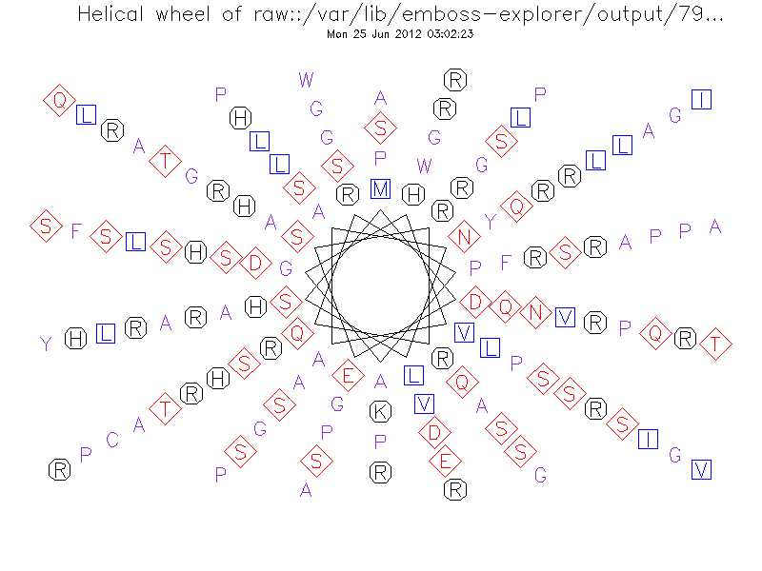
Figure-1
P04290 Serine threonine kinase

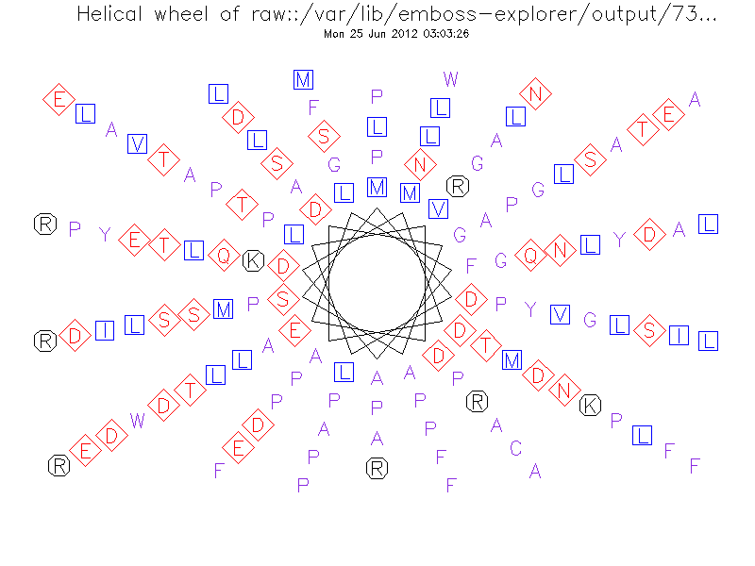
Figure-2
P04486 (HHV1F Tegument protein VP16)
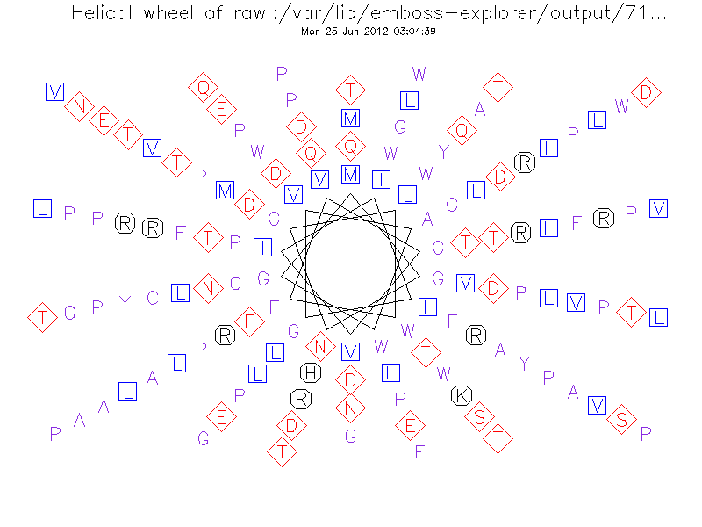
Figure-3
P06477 (HHV1F Envelope glycoprotein H)

Homology modelling by SWISS model structure
Figure-4 Figure-5
P06477 (HHV1F Envelope glycoprotein H) P04486 (HHV1F Tegument protein VP16

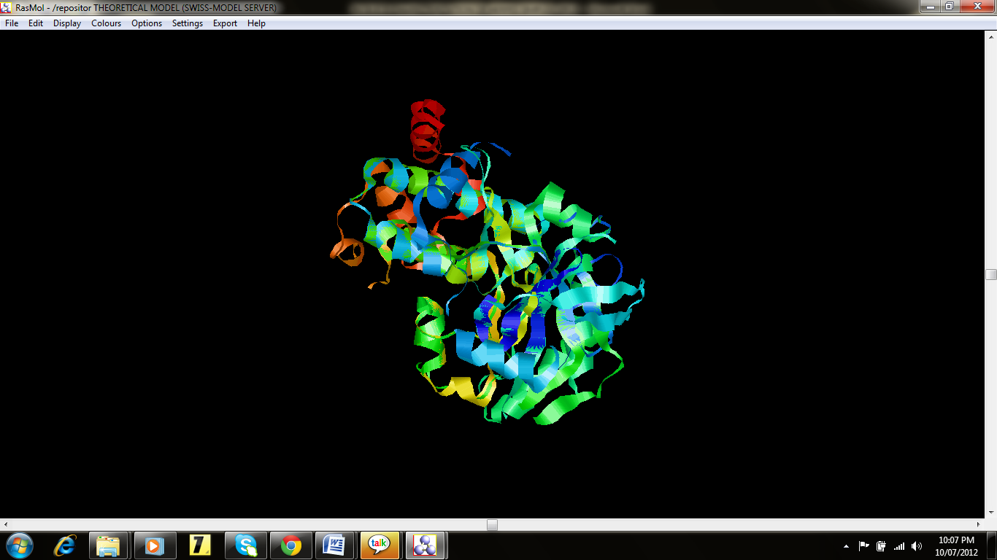
Figure-6
P04290 Serine threonine kinase

Conclusion
The modeled structure of proteins were also validated by other model verification server PROCHEK and What IF shows normal Z scores -1.40 for P04486,while the P06477 shows -2.80 suggesting quality of model. It is concluded that, these two structures which act as membrane protein and highly involved in interaction with host cell. Secondary structure shows that some are predominate alpha helices with random coils. Transmembrane region prediction by SOSUI server predicted that P04290 and contain only one transmembrane region while P06477 soluble protein. Four transmembrane regions found in P04486 protein all predicted regions were analyzed by the helical plots using EMBOSS pepwheel 6.1, these all the obtained data can be open the new horizons for the drug targeting, since the PDB is lacking a database of such a two proteins. 3D modelled proteins exact prediction, energy level which is valuable from docking point of view.

References
- Akhtar J. And Shukla D., Viral entry mechanism, cellular and viral mediators of herpes simplex virus entry, FEBS J, 276(24), 7228-7236 (2009)
- Connoliy S.A., Jackson J.O., et. al, Fusing structure and function a structural view of herpes machinery, Nat rev Microbiol, 9(5), 369-381 (2011)
- Akhtar M.J. et. al, A role hepain sulphate in viral surfing, Biochem Biophys Res Commun, 391(1), 176-81, (2010)
- Raquel Naldinho-Souto, Helena Browne and Tony Minson Herpes Simplex Virus Tegument Protein VP16 Is a Component of Primary Enveloped Virions, ncbi.nih.nic.gov.pmc (2009)
- Gupta Manish and Sharma Vimukta, Targeted drug delivery system: A Review, Res.J.Chem.Sci, 1(2) (2011)
- Donnelly M. and Elliott G., Fluorescent tagging of herpes simplex virus tegument protein VP13/14 in virus infection, J. Virol., 75, 2575-2583 (2001)
- Mishra Subhra, Characterization of Protein Interfaces to Infer Protein-Protein Interaction, Res.J.Chem.Sci., 2(7), 36-40 (2012)
- CLC bio., CLC free Workbench. http://www.clcbio.com/index.php?id=28, 27/10/2006 (2006)
- Gill S.C. and Von Hippel P.H., Calculation of protein extinction coefficients from amino acids sequences data, Anal. Biochem., 182-319 (1989)
- Bachmair A., Finley D. and Varshavsky A., In vivo half-life of aprotein is a function of its amino-terminal residue. Science, 234(4773), 179-186 (1986)
- Gonda D.K. and Bachmair A., et.al., Universality and structure of the N-end rule, J.Biol Chem, 264(28), 16700-16712 (1989)
- Tobias J.W., Shrader T.E., Rocap G. and Varshavsky A., The N-end rule in bacteria, Science, (254), 1374 (1991)
- Ciechanover A., Schwartz A.L., How are substrates recognized by the ubiquitin-mediated proteolytic system? Trends Biochem Sci., 14(12), 483–488 (1989)
- Guruprasad K., Reddy B.V.B. and Pandit M.W., Correlation between stability of a protein and its dipeptide composition: a novel approach for predicting in vivo stability of a protein from its primary sequence, Prot. Eng., (4) 155 (1990)
- Ikai A., Thermostability and Aliphatic Index of Globular Proteins, J. Biochem., (88), 1895 (1980)
- Kyte J. and Doolittle R.F., A simple method for displaying the hydropathic character of a protein, J. Mol. Biol., (157), 105 (1982)
- Blanchet C., Combet C., Geourjon C. and Deléage G., MPSA: integrated system for multiple protein sequence analysis with client/server capabilities, TIBS, 25(291), 147 (2000)
- Eisenhaber F., Imperiale F., Argos P. and Froemmel C., Prediction of Secondary Structural Content of Proteins from Their Amino Acid Composition Alone, Proteins Struct. Funct. Design, 25, 157 (1996)
- Takatsugu Hirokawa, Seah Boon-Chieng and Shigeki Mitaku, SOSUI: classification and secondary structure prediction system for membrane proteins, Bioinform. Appl, Note (14), 378 (1998)
- Ramachandran G.N. and Sasiskharan V., Conformation of polypeptides and proteins, Adv.Prot. Chem., (23) 283, (1968)
- Laskowski R.A., Rullmannn J.A., MacArthur M.W., Kaptein R. and Thornton J.M., AQUA and PROCHECK-NMR: programs for checking the quality of protein structures solved by NMR, J Biomol NMR, 8, 477-486 (1996)

