Review Paper
Investigating Flow Patterns in Wind Catchers with underground Tunnels
using Computational Fluid Dynamics

Amooie Morteza¹, Hooshmand Aini Ali², Hassanpanah Mostafa³ and Tasdighi Shadi³
¹Department of civil engineering, Bandar Anzali Branch, Islamic Azad University, Bandar Anzali, IRAN
²Department of civil engineering, Roudbar Branch, Islamic Azad University, Roudbar, IRAN
³Department of Mechanical Engineering, Sharif University of Technology, Tehran, IRAN

Available online at: www.isca.in
Received 1st July 2012, revised 9th August 2012, accepted 11th August 2012

Abstract
Taking the advantage of wind energy in ventilating residential places has been focused on since old times. Surely, using wind is important in making healthy and comfortable rooms for work and life, especially from the view point of enhancing the physical and mental performance of people and reducing consumption of non-renewing fuels. When wind flows around a building or enters from one side and then exits from the other side, natural ventilation occurs. Windscops can be used for pushing the air out to provide conditions to make a natural flow of air. Windtowers can be used for pulling the air inside and then let it flow freely in the room, So, A combination of windtowers and windscops could provide a natural flow through the area to be ventilated. A special kind of windtower can be used in a little distance from the building so that they guide air into underground channels into the building; used air after ventilating will exit through the windscop. In this paper, after describing how windtowers work, using CFD the performance of windtowers is investigated. For this aim at first geometrical model and meshing was performed in GAMBIT, then FLUENT was used to investigate the flow pattern in prescribed windtowers. Results of the analysis in form of flow pattern and velocity contours in X and Y direction are presented.

Keywords: Windscop – computational fluid dynamics – air flow pattern – energy consumption optimization in buildings – heating, ventilating and air conditioning.

Introduction
Surely using wind flow is important in providing healthy and comfortable places for human being work and life, from the view point of enhancing physical and mental efficiency of individuals, reducing diseases and reducing non-renewing polluting fuel consumption. Since industrial revolution, about 250 years ago, human kind’s reliance on energy particularly fossil energy has increased exponentially. In spite of using fuel was vital to industrial production, transportation and human kind welfare, it was the cause for polluting and destroying the environment that results in endangerment of ecosystem and life on Earth.

Regarding this issue, since the second half of the 20th century especially the 70s environmental protection has been continually under consideration and wide variety of environmental advocacy groups have been constituted. These groups often wanted the environment to be restored, the technology to be in harmony with natural environment, recycling industrial wastes and using clean energies like solar, wind and water energy.

In Europe about half of the total energy is used in buildings and between 30 to 40 percent of CO₂ is emitted from buildings. In Middle East, as shown in figure-1 despite the small population, CO₂ emission is more than the universal average¹.

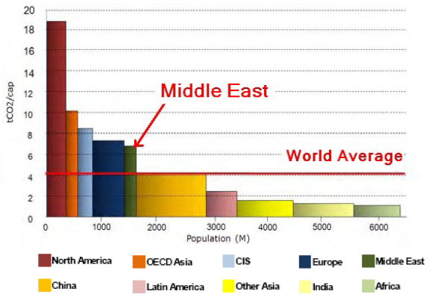
Figure-1
CO₂ emission in different regions around the world¹
A big proportion of the total energy consumed in buildings is used for ventilating. Hence, the natural ventilating issue should be considered as an important constructional environmental issue. To construct a building with low maintenance and energy costs, and at the same time high quality environmentally, traditional and simple ways in primary steps of design should be considered. In architecture considering environmental constraints and constructing buildings in harmony with nature has begun since then. During last 30 years, number of eco-friendly buildings has increased and new methods, articles and books have developed in a wide range.

Windscops and Windtowers

When wind flows around a building or enters from one side and exits from another side, results in natural ventilation and can be used in different ways. Windscops can push the air out and make a natural flow of air. Windtowers can pull the outside air into the area. A combination of windtowers and windscops can complete the natural air flow in a building.

The simplest design for a windscop is a non-covered vertical structure that is higher than its surroundings. Such a structure causes negative pressure and consequently suction in all directions. If it is important to prevent rain from entering the building, it is possible to put a cap on it or use a kneed windscop that is resistant to atmospheric turbulences, as shown in figure-2.

But if a kneed windscop is to be used in all directions, it is to be designed to change its direction with the direction of wind. Such a design will be very difficult and expensive for maintenance and repair. It is possible to add some other equipment to the main channel of the windscop to make more negative pressure, but the described equipment has to be multi-sided also.

Windtowers are designed to catch the wind and guide it into the building as depicted in figure-3. For being an effective windtower, it has to be multi-sided or change its direction along the wind direction. If a windtower is fixed and its head is not aligned with the direction of wind it will get useless soon or act as a kneed windscop. The performance of wind towers reaches its maximum when they are used to make fresh air for wide spaces. Under these conditions it is possible for cool air to go down and get mixed with the air in lower areas. Windtowers can be placed on rooftops or in the yard so that fresh air can be guided to underground channels².

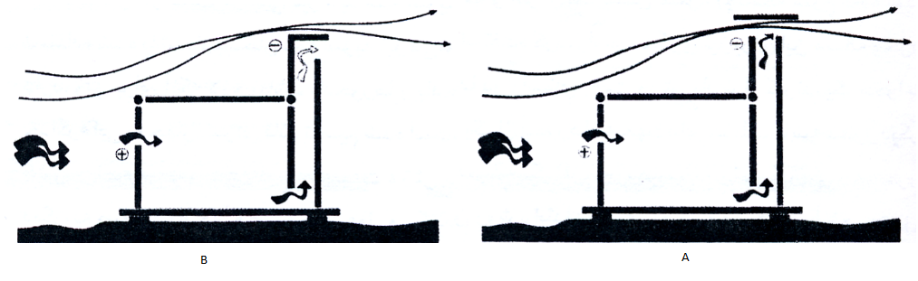
Figure-2
A. a windscop with its cap B. a kneed windscop²

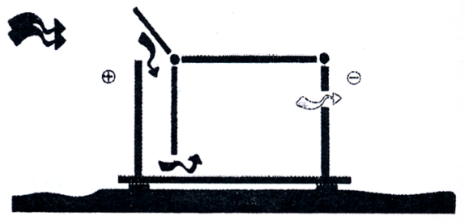
Figure-3
Windtowers guide air into the building²

Windtowers can be used in combination with windscops. Fresh and cool air will come in through windtowers and stuffy air will go out through windscops. If entering and exiting of air occurs in high altitudes the pressure difference will increase and the air flow will increase too. Natural ventilation using windscops and windtowers both could be done with two separate channels and with one channel having an entry and an exit.

A windtower in the combined mode has to be multi-sided and if it uses a single channel the windscop could be multi-sided. This problem has another solution. To eliminate the need for windtowers and windscops to be multisided or necessarily oriented along the direction of wind, the channel is separated into 4 vertical channels. One of the four channels, regardless of the direction of wind always catches the wind and the others act as kneed windscops. This solution was first practiced in Iran, under the title of windcatcher³ as described in figure-4.

Windcatchers are samples of Iran’s engineering marvels which do not have any known inventors⁴. The ancient city of Yazd is famous as the city of windcatchers. Yazd has more windcatchers relative to other central cities of Persia⁵.

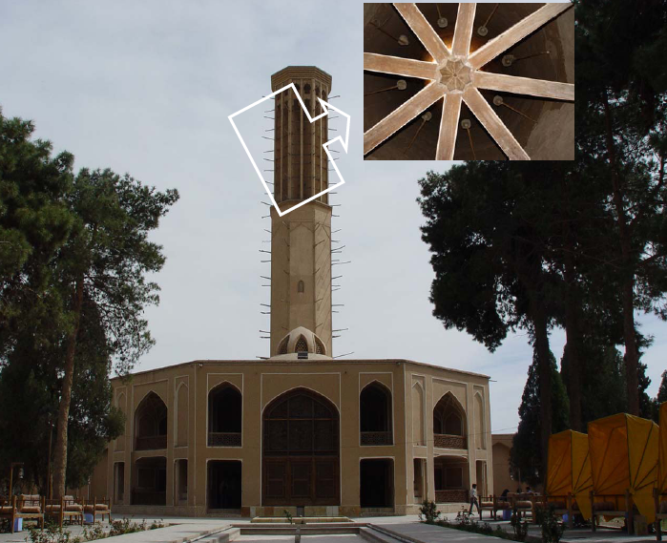
Figure-4
Dolat Abad Garden Emara and bottom view of the windcatcher

Numerical Modeling
There are three ways to solve problems related to fluid mechanics including: experimental, analytical and numerical. Development of numerical methods in various sciences has been remarkable over the last few decades. Due to the high costs of experimental methods and weakness of analytical techniques in solving engineering problems, most researchers have turned to usage of numerical methods.

In order to know the behavior of airflow through the windtower with underground duct, geometry of structure was created in Gambit software using the existing maps and sketches as illustrated in figure-5. As can be seen in figure-5 two boundary conditions of “inlet speed” and “outlet pressure” have been used to solve the problem. And simply all the effects due to natural convection are neglected. Then the geometry is transferred to Fluent^{6, 7}.

In this paper, the k-$ε$ model has been chosen as turbulence model. k-$ε$ Model is a relatively complete and general model but it is very expensive⁸. k-$ε$ Model is used to explain and describe turbulence and it is useful for description of transportation turbulence properties by the mean flow, diffusion and also for generation and deterioration of turbulence. In this model two transport equations (partial differential equations; PDE), one for turbulent kinetic energy k and the other for deterioration rate of turbulent kinetic energy $ε$ have been solved⁹.

Fluent k-$ε$ Standard model uses transport equations (1) and (2) which are for ε and k¹⁰.

(1)
(2)

(3)
Where, $k=Turbulent kinetic energy (per unit of mass)$, $α_{t}=Eddy viscosity$

Equations contain five adjustable constants which have the following values: $σ_{K}=1.0 C_{α}=0.09 C_{1ε}=1.44 C_{2ε}=1.92 σ_{ε}=1.30, G_{k}=$ Turbulent kinetic energy term due to average velocity gradient, $G_{b}=$ Turbulent kinetic energy term due to buoyancy force

In order to investigate the flow pattern in the windtower, 3 modes have been considered. In the first case V= 2 $\frac{m}{s}$ , in the second case V= 5 $\frac{m}{s}$ and in the third case V= 10 $\frac{m}{s}$ have been supposed. Getting the flow solved, the results are given in figure 6 to figure 9 and also minimum and maximum velocity values of X and Y direction in 3 presumed cases are given in tables 1 to 3.

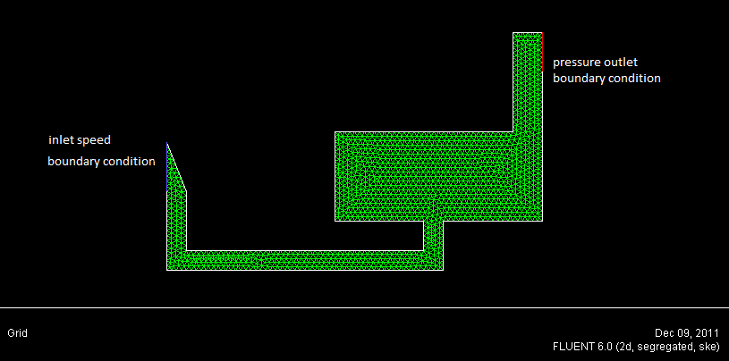
Figure-5
Geometrical model, meshing and boundary conditions applied

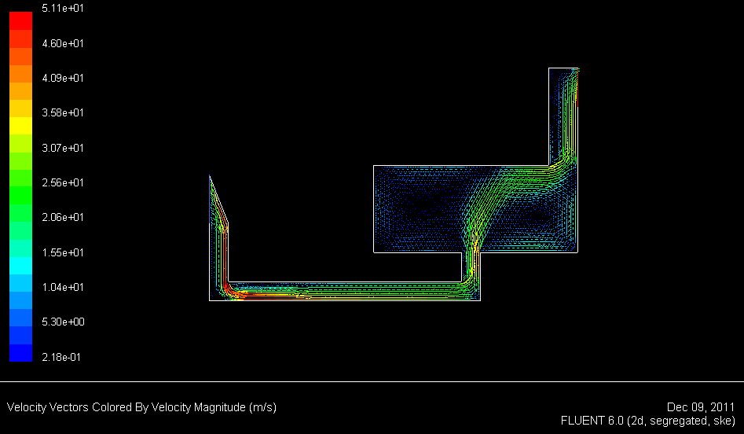
Figure-6
Velocity vectors colored by velocity magnitude
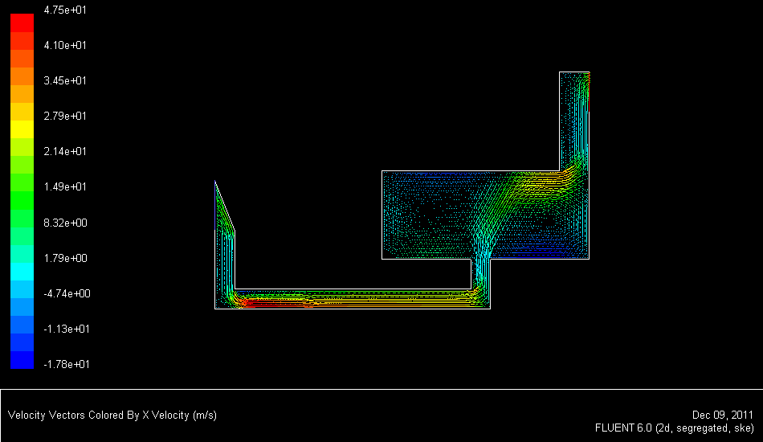
Figure-7
Velocity vectors colored by X-direction Velocity
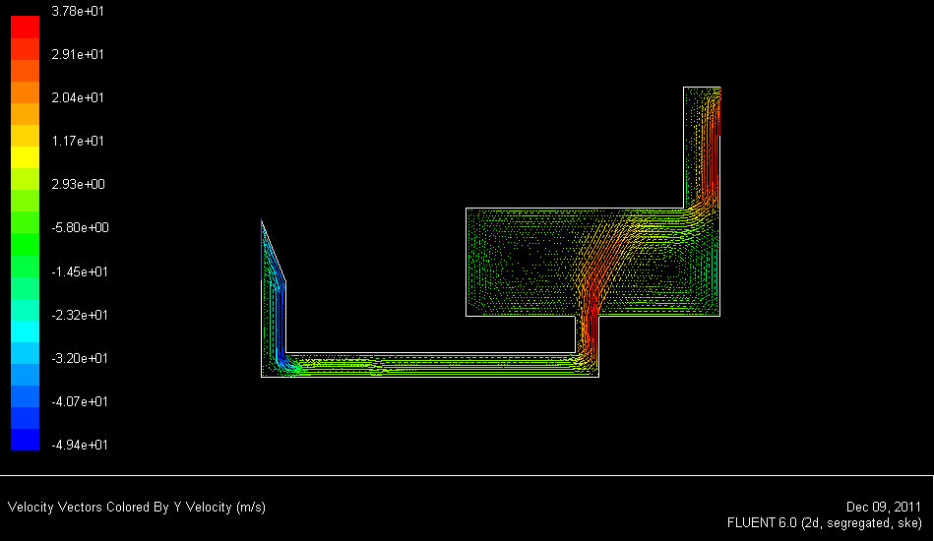
Figure-8
Velocity vectors colored by Y-direction Velocity
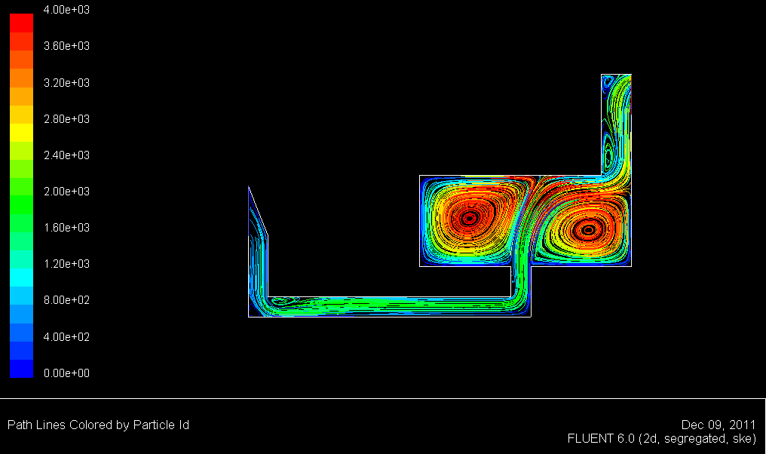
Figure-9
Path lines

Table-1
Minimum and maximum velocity values in the first mode (V= 2$\frac{m}{s}$)
 | Velocity Magnitude | Velocity in X-direction | Velocity in Y-direction
Minimum | 0.04 | -2.93 | -8.89
Maximum | 9.25 | 8.54 | 7.59

Table-2
Minimum and maximum velocity values in the second mode (V= 5$\frac{m}{s}$)
 | Velocity Magnitude | Velocity in X-direction | Velocity in Y-direction
Minimum | 0.12 | -8.52 | -23.91
Maximum | 24.77 | 22.78 | 18.93

Table-3
Minimum and maximum velocity values in the third mode (V= 10$\frac{m}{s}$)
 | Velocity Magnitude | Velocity in X-direction | Velocity in Y-direction
Minimum | 0.22 | -17.80 | -49.43
Maximum | 51.08 | 47.51 | 37.84

Conclusion
This study was conducted to investigate the Flow Patterns in wind catchers with underground tunnels using computational fluid dynamics. The following results can be drawn based on the numerical study: Maximum velocity vectors in X-direction, occurred in a section where there is more horizontal flow and the maximum value has occurred at the inlet section of the windtower, as shown in figure-7. Minimum velocity vectors in X-direction, occurred in a section where there is more vertical flow, in the vertical section of the windtower, inlet of the windtower and the windscop section, as shown in figure-7. Maximum value of velocity vectors in positive Y-direction has occurred at the inlet of the windtower and the windscop section, as shown in figure-8. Maximum value of velocity vectors in negative Y-direction has occurred at the vertical section of windtower, as shown in figure-8. In some parts of the model, in the first case (V= 2 $\frac{m}{s}$) , velocity magnitude, velocity in the X-direction and velocity in the Y-direction are equal to 4.62, 4.27 and 3.79, in the second case (V= 5 $\frac{m}{s}$) , velocity magnitude, velocity in the X-direction and velocity in the Y-direction are equal to 4.95, 4.55 and 3.78, in the third case (V= 10 $\frac{m}{s}$) , velocity magnitude, velocity in the X-direction and velocity in the Y-direction are equal to 5.10, 4.75 and 3.79, respectively. As a result with winds having different speeds, significant increase in velocity magnitude, velocity in the X-direction and velocity in the Y-direction will occur in some parts of the model. In the all 3 cases, velocity in the X and Y directions are greater than the wind velocity at the inlet of the windscop, data is given in tables-1,2,3.

References
- Bahadory Nejad M. and Dehghani A., Windcatchers; Iranian Masterpiece of Engineering, Nashr Ketab Daneshgahi, 190-198 (2008)

- World Energy Council, Energy Efficiency Policies around the World: Review and Evaluation, World Energy Council, 8-12 (2008)

- McCarty Consultant Engineers, Windscops (wind skeletal considerations in buildings) (2008)

- Shojaie Fard M. and Noorpour Hashtroudi A., Introduction to Computational Fluid Dynamics, Iranian University of Science and Technology (2007)

- Soltani M., Rahimi Asl R., Computational Fluid Dynamics using Fluent, Tarrah (2007)

- Nejad A.T., Storm of Inattention against Windcatchers in Yazd, Jam e Jam Newspaper, 15 (2011)

- Vetr M.G., Investigating Vulnerability of the Tallest Windcatcher around the Globe, Yazd Dolat Abad garden against Wind and Earthquake, First International Conference on Seismic Retrofitting (2006)

- Wolfgang R., Turbulence Models and their Application in Hydraulic: A state-of-the art Review. International Association for Hydraulic Research, Delft, 27 (1984)

- Thundil Karuppa Raj R. and Ramsai R., Numerical study of fluid flow and effect of inlet pipe angle in catalytic converter using CFD, Res. J. Recent Sci, 1(7), 39-44 (2012)

- Ipatova V.M., Convergence of Numerical Solutions of the Data Assimilation Problem for the Atmospheric General Circulation Model, Res. J. Recent Sci., 1(6), 16-21 (2012)

