Review Paper
Overcoming Additional Investment to Meet Customer Needs by Applying Smed/Qco Tool – A Study

Baishya Nystha, Rao Sathish U.² and Diwakar Sharath

¹Manipal Institute of Technology, Manipal, Karnataka, INDIA

²Mechanical and Manufacturing Engineering, Manipal Institute of Technology, Manipal, Karnataka, INDIA
³BANP/PJ-CRR21, RBIN, Bangalore, Karnataka, INDIA

Available online at: www.isca.in
Received 31st March 2012, revised 7th June 2012, accepted 19th July 2012

Abstract
Nowadays the market is increasingly demanding more customized products, thus making the manufacturers under the pressure of cost reduction, to survive in the highly competitive market. Working on this, Robert Bosch India (RBIN) Limited, Bangalore Plant (BanP) designs and produces diesel systems which make vehicles more cleaner and economical. To be the world’s leading manufacturer of diesel injection systems, Bosch has to manufacture its very own design to fulfill the requirements for every customers, economically. Fuel injection equipment in diesel engine is the “Heart of the Engine” and plays a major role in its performance, emissions and reliability. Hot Forged Rail (HFR) finds its application in common rail fuel injection system, which stores the fuel at high pressure (1600bar). And at the same time, the pressure oscillation, which is generated due to the high pressure pump delivery and the injection of fuel are damped by the rail volume. Its design varies according to customer requirement and engine design. Therefore, BanP has to produce different types of rails to complete diesel market in India. In order to be customer centric and productive, BOSCH follows Bosch Production Systems (BPS), the elements of BPS in Lean manufacturing are Value Stream Mapping (VSM), Value Stream Design (VSD) and Value Stream Planning (VSP). The Single Minute Exchange of Die (SMED) is one important lean manufacturing tool to reduce waste and improve production flexibility, allowing lot size reduction and manufacturing flow improvements. Quick Change Over (QCO) is a set of activities (preparation, changing and adjustment) which are being carried out in between the production of two varieties to reduce changeover time and to reach the optimum production running. The proposed SMED approach was tested for injection machines changeovers in the automotive industry and the implementation had enabled reduction in setup time, through company’s internal resources reorganizations without the need for significant investment. So, the objective of the present study is to implement the same technique in RBIN, BanP, HFR production line to reduce the changeover time by >65% and improve availability by 15% using SMED/QCO tool approach, thereby eliminating the possibility of investing on a new production line to meet the customer demand.

Keywords: Bosch production systems (BPS), value stream mapping (VSM), value stream design (VSD), value stream planning (VSP), quick change over (QCO), single minute exchange of die (SMED), hot forged rail (HFR).

Introduction
While the market is increasingly demanding more customized products, manufacturers are under constant pressure to produce variety at low costs. Non-fulfillment of orders more frequently results in losing business to the competition. Combining these factors with the high cost of inventory and the need to increase productivity, and it becomes obvious that mastering quick changeover is essential to an organization’s survival¹.

As an organization begins a lean manufacturing implementation, its ultimate goal is to produce according to customer demand (takt time) while utilizing “one piece flow.” For this to happen, machines need to be set up more often, highlighting the need to reduce setup time. Reducing setup time results in increased production, better quality parts and a more flexible workplace without much investment^{2,3}.
Single Minute Exchange of Dies
Single-Minute Exchange of Die (SMED) is one of the many lean production methods for reducing waste in a manufacturing process. It provides a rapid and efficient way of converting a manufacturing process from running the current product to running the next product. The phrase "single minute" does not mean that all changeovers and startups should take only one minute, but that they should take less than 10 minutes (in other words, "single-digit minute").

Single-minute exchange of dies (SMED), like other lean tools, requires a committed effort from within the organization. One of the major pitfalls organizations fall into is the desire to rush into a changeover program with very little or no upfront planning. With limited time and resources, the program is doomed for failure. The other common mistake is failure to document and standardize the process⁴.

Formal method of SMED
There are seven basic steps to reducing changeover using the smed system: i. observe the current methodology (A), ii. Separate the internal and external activities (B). Internal activities are those that can only be performed when the process is stopped, while External activities can be done while the last batch is being produced, or once the next batch has started. For example, go and get the required tools for the job before the machine stops. iii. Convert (where possible) Internal activities into External ones (C) (pre-heating of tools is a good example of this). iv. Streamline the remaining internal activities, by simplifying them (D). Focus on fixings - Shigeo Shingo observed that it's only the last turn of a bolt that tightens it - the rest is just movement. v. Streamline the External activities, so that they are of a similar scale to the Internal ones (D). vi. Document the new procedure, and actions that are yet to be completed. vii. Do it all again: For each iteration of the above process, a 45% improvement in set-up times should be expected, so it may take several iterations to cross the ten minute line^{5,6}.

Quick Change over (QCO)
Quick changeover incorporates proven, simple process orientated systems and methods to reduce tools, plant or equipment changeover times to facilitate increased capacity, smaller batch sizes, more agility to changing demands, lower inventory and reduced lead times.

Most of the companies face this business paradigm, where they have ever increasing requests for smaller and more frequent deliveries, changing demands requested at short notice and orders for specials or some form of uniqueness and customization of the products and services they provide and at low price. The solution is in batch size reduction, quick response and flexibility, through mastering quick changeover and standardization.

The keys to quick changeover are as follows: i. Rethinking the idea that machines can be idle, but workers cannot be idle. ii. The ideal setup change is no setup at all or within seconds. iii. Ensuring that all tools are always ready and in perfect condition. iv. Blowing a whistle and have a team of workers respond to each changeover. v. Establishing goals to reduce changeover times, record all changeover times and display them near the machine. vi. Distinguishing between internal and external setup activities and try to convert internal to external setup⁷.

Basic Terms used in QCO
The time from the last part of the old lot to the first okay part of the new lot is known as ‘Loss of change over time’. The ‘Internal change over time’ is the change over time with the plant stopped. The loss of output due to stoppage and running (incl. Release of production) in an operating system through change over processes is known as ‘Gap in Change Over’. Adding all internal and external change over processes gives the ‘duration of change over’. The ‘External change over time’ is the change over time when the machine is running. The ‘Change over frequency’ is the number of change over processes per unit of time⁸.

The advantages of QCO
Reduce defect rates: Quick Changeover reduces adjustments as part of setup and promotes quality on the first piece. Reduce inventory costs: Elimination of, or reduction in numbers of batches, and their sizes, allows for recovery of operating cash and manufacturing space.

Increase production flexibility: Increase output and improve timeliness of response to customer orders.

Improve on-time delivery: Quick Changeover supports the ability to meet customer demands.

The advantages for the employees
Easier: Easier and more transparent change over processes causes less problems (and with that less stress and hectic), uniform work load of all the employees.

Quicker: quicker change over time gives more time for other work.

Safer: less physical strain during change over, planning safety during the production process⁹.

Four steps to SMED
To start, identify and separate the changeover process into key operations – External Setup involves operations that can be done while the machine is running and before the changeover process begins, Internal Setup are those that must take place when the equipment is stopped. Aside from that, there may also be non-essential operations. The following are the four main steps to attack the quick changeover: i. Eliminate non-essential operations – Adjust only one side of guard rails instead of both, replace only necessary parts and make all others as universal as possible. ii. Perform External Set-up – Gather parts and tools, pre-heat dies, have the correct new product material at the line… there's nothing worse than completing a changeover only to find that a key product component is missing. iii. Simplify Internal Set-up – Use pins, cams, and jigs to reduce adjustments, replace nuts and bolts with hand knobs, levers and toggle clamps… remember that no matter how long the screw or bolt only the last turn tightens it. iv. Measure, measure, measure – The only way to know if changeover time and startup waste is reduced to measure it.⁹

Need for SMED
The customer demands in 2012 increased by ~87% (50,000 pieces of rails in 2011 and 4,00,000 pieces in 2012). Following the BPS principles, a VSM was prepared in January which depicted the current picture of the assembly line. And consequently, a VSD was also prepared predicting the future state. The gap between the two conditions was studied and a system CIP workshop was conducted. In this, various projects were identified and SMED was proposed for Oiling and Throttle Pressing station.

Steps for Implementation at BOSCH: The Implementation comprises of eight steps-

Analyzing the present condition at Bosch: Presently, at Bosch the following different types of rails like 002, 004, 007, 261, 125, 006, 299, 224 and 019 are produced for customers like Mahindra and Mahindra, Tata, Suzuki, etc. And each of the rails has its own unique design according to the engine design. Thus, when the parts pass through various stations for the assembly and testing, various change overs in the stations must be made. The general change over matrix, which depicts the time taken for change over from one part to other, in the current scenario looks like as shown in table-1 below:

Table-1
Time taken for change over from one part to other
 | 002 | 004 | 007 | 261 | 025 | 006 | 299 | 224 | 019
002 | --- | 8 | 8 | 30 | 30 | 30 | 20 | 20 | 20
004 | 8 | --- | 8 | 30 | 30 | 30 | 20 | 20 | 20
007 | 8 | 8 | --- | 30 | 30 | 30 | 20 | 20 | 20
261 | 30 | 30 | 30 | --- | 8 | 30 | 20 | 20 | 20
025 | 30 | 30 | 30 | 8 | --- | 30 | 20 | 20 | 20
006 | 30 | 30 | 30 | 15 | 15 | --- | 20 | 20 | 20
299 | 20 | 20 | 20 | 20 | 20 | 15 | --- | 15 | 20
224 | 20 | 20 | 20 | 20 | 20 | 15 | 15 | --- | 20
019 | 20 | 20 | 20 | 20 | 20 | 15 | 20 | 20 | ---
*Highlighted numbers represent the change over time at the Oiling and Throttle Pressing station.

And the change over matrix for Oiling and Throttle Pressing alone looks like the following:
Table-2
Oiling and Throttle Pressing Station CO matrix
 | 002 | 004 | 007 | 261 | 025 | 006
002 | --- | 2 | 2 | 30 | 30 | 30
004 | 2 | --- | 2 | 30 | 30 | 30
007 | 2 | 2 | --- | 30 | 30 | 30
261 | 30 | 30 | 30 | --- | 3 | 30
025 | 30 | 30 | 30 | 3 | --- | 30
006 | 30 | 30 | 30 | 30 | 30 | ---

Table-3
Throttle types
002 | F00R.003.106
004 | F00R.003.106
007 | F00R.003.106
261 | F00R.003.296
025 | F00R.003.505
006 | F00R.003.270

Segregation of Internal and External Activities: The following change over procedure is followed in the Oiling and Throttle Pressing Station (at present): Internal Activities: i. stop the machine, ii. stop the pneumatic flow, iii. Remove the four holding screws: 3mins, iv. remove the two alignment screws: 2mins, v. disconnect the sensor cables: 2mins, vi. Take out the current running fixture for a certain type: 5mins, vii. Replace with the new fixture: 3mins, viii. Screw back the alignment screws: 1min, ix. Screw the four holding screws: 2mins, x. Connect the sensor cables: 2mins, xi. Change the throttle pressing pin: 2mins, xii. Change the program in the machine: 2mins, xiii. Replace the o-ring if it gets damaged: 2mins.

External Activities: i. Bring the fixture and the change over tools 2 mins, ii. Replace the fixture and change over tools 2 mins.
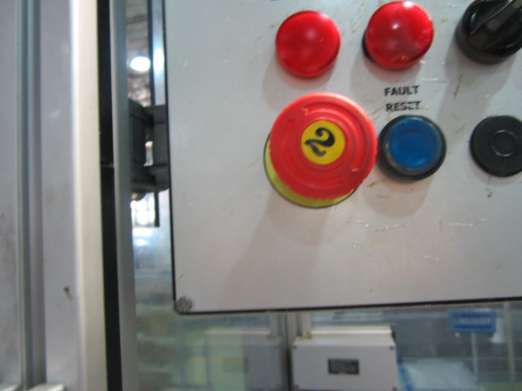

Figure-1
Stop the machine (step i)
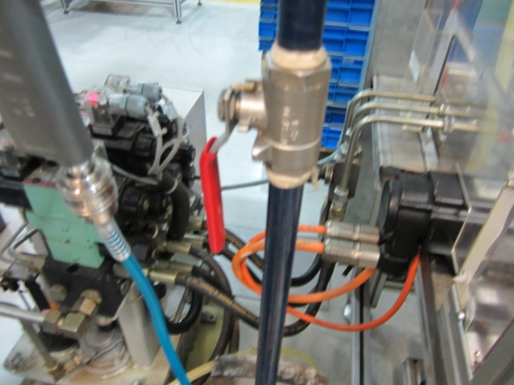

Figure-2
Stop the pneumatic flow (step ii)
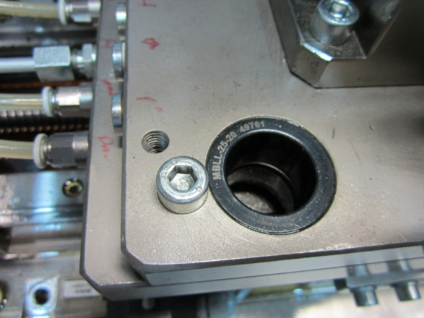

Figure-3
Remove the four holding screws (step iii) and two alignment screws (step ix)

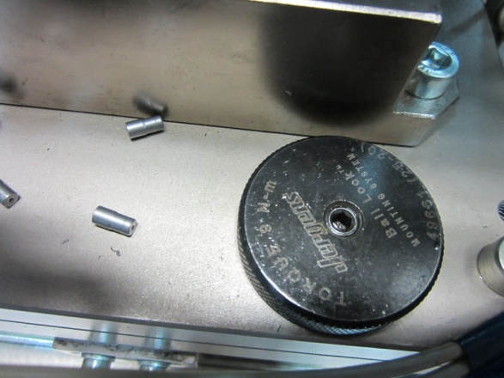

Figure-4
Remove the two alignment screws (step iv) and screw back the alignment screws (step viii)
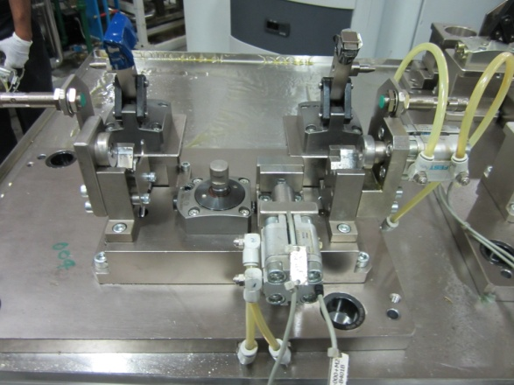

Figure- 5
Take out the current fixture (step vi) and replace with new fixture (step vii)
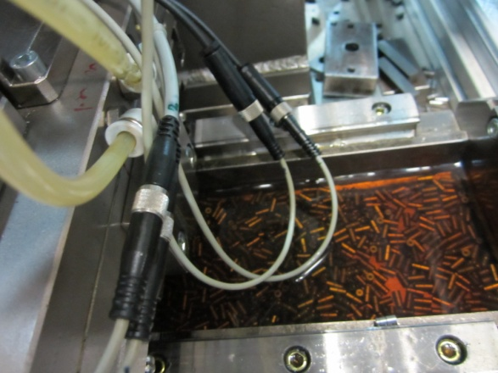

Figure-6
Disconnect the Sensor Cables (step v) and Connect the Sensor Cables (step x)
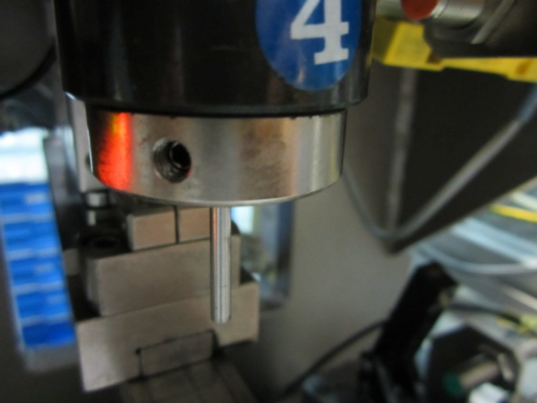

Figure-7
Change the throttle pressing pin (step ix)

Thus, in the current scenario, if rails have to be produced in smaller lots daily, the availability loss due to change over’s alone will be > 20% which will lead to an investment of a second line to cater the customer requirements from Jun’12.

Shifting the Internal activities to External: Keeping in mind the safety of the operator, this was not possible.

Localization of parallel activities: Not Possible

Rationalization of Internal and External Activities: Internal Activities: i. Unscrew the four screws of the sliding part 3mins, ii. Slide it to the required length as per the markings of the bed: 1min, iii. Screw back the four screws: 2mins

And for part change from 90 degrees to 180 degree: Internal activities: i. Unscrew the two screws for the clamping part: 2mins, ii. Screw back the part: 2mins, iii. Unscrew the two screws for the butt part: 2mins, iv. Screw the part: 2mins.

External Activities: i. Bring the change over tools: 2mins, ii. Bring the clamping and the butting part (for parts with change in angle): 2mins, iii. Replace the present fixtures: 2mins.

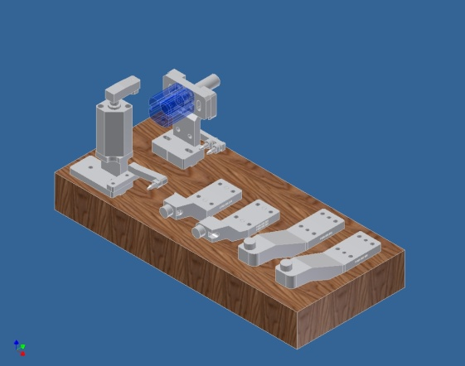
Figure-8
Arts to be changed after the project
Table-4
The new changeover matrix
 | 002 | 004 | 007 | 261 | 025 | 006
002 | --- | 2 | 2 | 10 | 10 | 14
004 | 2 | --- | 2 | 10 | 10 | 14
007 | 2 | 2 | --- | 10 | 10 | 14
261 | 10 | 10 | 10 | --- | 3 | 14
025 | 10 | 10 | 10 | 3 | --- | 14
006 | 14 | 14 | 14 | 14 | 14 | ---

Implementation of the project: The following steps are to be followed for the proper implementation of the project: i. Feasibility of the project of having changeover concept at oiling and throttle pressing, ii. Identification of runner types for the next 5yrs, iii. Detailed study of the drawing for conceptualization, iv. Detailed study of the machine, v. Design of fixtures, vi. Proto generation and design check, vii. Manufacturing of fixtures, viii. Trials with samples, ix. Capability analysis, x. SOP with new fixtures

Testing of the result: For the smooth running of the process, the following analyses are to be made: i. Capability analysis, ii. Productivity analysis.

Standardization: With more new orders coming, this will reduce the change over time to quite a large extent.

Figure–9
Comparison of Throttle Pressing Change Over

Conclusions
The implementation of this project will help BOSCH, HFR division to reduce the changeover time by 66% and thus increased the availability of the throttle pressing machine by 15%. With new varieties coming each day and new customers adding up the list, this project will help in catering the customer demands of 2012 which is increased by 87%.

Acknowledgement
This project is a result of support, guidance, help, suggestions, cooperation, sharing of information and criticisms from many people who surround me, especially my teacher and guide Mr. Sathish Rao U and Mr. Sharath D, a mentor and friend. A special thanks to Bosch Ltd. Bangalore, for providing me this wonderful opportunity to be a part of this esteemed organization and undergo my final semester project here. I would also like to take this opportunity to thank all my associates Mr. Satish Kumar G., Mr. Shashidhar N, Mr. Virupaksha N and Ms. Sneha C for being a constant support and sharing their valuable experience and time with me.

References
- Quick Change Over for Operators, The Single Minute Exchange of Dies System Productivity Press, Portland, Oregon, ISBN: 1 - 56 327 - 125 – 7, (2008)
- A Revolution in Manufacturing: The SMED System, Shigeo Shingo; Productivity Press, Portland, Oregon, ISBN: 0 - 915 299 - 03 – 8 (2001)
- John P. Leschke, An Empirical Study of the SetupReduction Process, Production And Operations Management, 5(2) (1996)
- Gilmore M. and Smith D.J., Set‐up reduction in pharmaceutical manufacturing: an action research study, International Journal of Operations and Production Management, 16(3), 4–17 (1996)
- Moxham C. and Greatbanks R., Prerequisites for the implementation of the SMED methodology: A study in a textile processing environment, International Journal of Quality, Reliability, 18(4), 404–414 (2001)
- Johansen P. and McGuire K. J., A Lesson in SMED With Shigeo Shingo, Industrial Engineering, 8(10), (1986)
- Cakmakci M., Process improvement: performance analysis of the setup time reduction‐SMED in the automobile industry, International Journal of Advanced Manufacturing Technology, 41, 168–179 (2009)
- Idle Time Reduction in metal working through quick changeover techniques, A seminar held at UNIDO-ICAMT Building, CMTI Campus, Bangalore, 27 October (2010)
- Shams Rahman, Tritos Laosirihongthong, Amrik S. Sohal, Impact of lean strategy on operational performance: a study of Thai manufacturing companies, Emerald 21, (2010)
- B. Suresh Kumar and S. Syath Abuthakeer, “Implementation of Lean Tools and Techniques in an Automotive Industry”. Journal of Applied Sciences,: pp1032-1037,(2012)
- http://www.aleanjourney.com/2010/08
- http://en.wikipedia.org/wiki/Single_Minute_Exchange_of_Die
- www.wikipedia.org/wiki/Single_minute_exchange of _die
- http://world-class-manufacturing.com/smed.html
- www.vorne.com>Learning Center
- www.leanpresentations.com/samples/.../QuickSMED_sample.ppt
- www.francespecialtool.com/smed.htm
- leanman.hubpages.com› AllTopics › Busines and Employment

