Short Communication

Using Ultrasonic Sensor for Blind and Deaf persons Combines Voice

Alert and Vibration Properties

Mahdi Safaa A., Muhsin Asaad H. and Al-Mosawi Ali I.
Technical Institute – Babylon, IRAQ

Available online at: www.isca.in
Received 17th August 2012, revised 31st August 2012, accepted 2nd September 2012

Abstract
Persons who are blind and deaf frequently suffering when exercising the most basic things of daily life and that could put lives at risk while traveling, due to the lack of necessary equipment in our country that provides them with assistance to avoid the risk, so came the idea of ​​this research in the design and manufacturing ultrasonic sensor handheld combines the properties of sound monition and that benefit the blind and vibrating alert feature, which benefit from the experience of deafness. Sensor can detect obstacles within the designed range (150 cm) to avoid the blind person through the issuance of distinctive sound or vibration can be issued by the sense of the deaf by putting his finger on the button at the top of the device vibrate when there is a risk.

Keywords: Ultrasonic sensor, voice alert and vibration properties.

Introduction
There are a millions blind or deaf persons around the world, and Many of these persons use the white cane which the most successful and widely used travel aid for the blind but not used from deaf persons. White cane purely mechanical device is used to detect obstacles on the ground, uneven surfaces, holes, steps, and other hazards¹. The main problem with this device is that users must be trained in its use for more than 100 hours; in addition, the white cane requires the user to actively scan the small area ahead of him/her². The white cane is also not suited for detecting potentially dangerous obstacles at head level³.

Guide dogs are very capable guides for the blind, but they require extensive training, and they are only useful for about five years. Furthermore, many blind and visually impaired people are elderly and find it difficult to care appropriately for another living being⁴. Also (GPS) based voice alert system for the blind uses the current location and gives the alert to the blind person if it was his destination area⁵. The deaf persons can see the obstacles, but they cannot hear the sounds such as cars horns which will be a real dangerous on them lives, also they cannot benefits from (GPS) which alerted with the help of audible messages using a voice synthesizer⁶.

Ultrasonic devices and Bluetooth technology can be used in modern high-speed motorways and vehicles that drive upon them are becoming increasingly intelligent. In particular, communication devices are being installed in more and more cars and roadside infrastructure components (for example Volkswagen polo car). In the not-too-distant future, traveling vehicles will be able to communicate while forming ephemeral, rapidly changing ad hoc networks. At the same time, they will have direct access to a fixed roadside network infrastructure with information flowing both ways. This network environment motivates the need for an infrastructure that will provide drivers with access to the road map. The resulting enhanced situational awareness has the potential to not only facilitate the decision making tasks of the drivers (e.g., trip planning based on traffic congestion on the road), but also to improve highway safety (by bringing information about catastrophic events and road conditions to the driver’s attention)⁷.

Material and Methods
The ultrasonic sensor system in this paper is designed to combine two parts: voice alert part for blind persons which will send voice as in car sensors, and vibration part for deaf persons which as a rod vibrated when approached from obstacles. Figure-1 show the device diagram used in this paper. Table-1 show specifications of blind and deaf device.

Table-1
Specifications of blind and deaf device
Detection range | Detection angle | Transmitter frequency | Sample frequency | Power supply
40-150 cm | 5º | 40 KHz | 28 Hz | 10-15 VDC
Head Phone
Charger
Power Switch
Ultrasonic Sensor
Vibrator Rod

Figure-1
Diagram of blind and deaf assist device
Figure 2 shows the real picture to blind and deaf device, and figure 3 shows blind and deaf device system block diagram. This a portable device can be used in three dimensions.
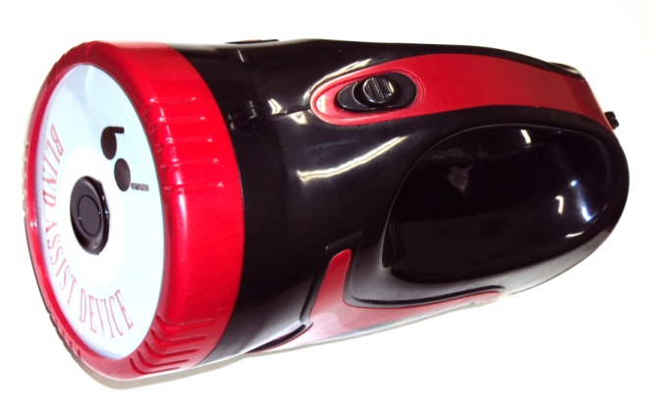

Figure- 2
Real picture to blind and deaf device

Barking radar
system
Battery
12V
1.3A
Sensor
Buzzer
Vibrator Rod
+
-

Figure-3
Blind and deaf device system block diagram

Results and Discusion
The practice range of blind and deaf device as we mentioned in table-1 is (40-150 cm) after we tested the device we get the experiment results show in table-2. From this table we see that with distances (10-30 cm) alert signal will be continuous as in car sensor which meaning that there is no safety distance between person and obstacle⁸. While in distances between ranges (40-70 cm) the alert signal very fast when the obstacle closed near from person. Also the vibrator rod will vibrated very fast as signal to caution deaf person⁹. When the distance increased to the range (80-110 cm) the voice and vibration of device will be fast because the obstacle became near from blind or deaf and they should be avoided this obstacle. In the range (120-150 cm) the signal slow because there will be safety distance between person and obstacle¹⁰. Figure- 4 shows the range of blind and deaf device. In figure 4 D: distance between device and obstacle in cm, T: time between impulses in sec, S: alert signal.

Table-2
Experiment results
D ,cm | T ,sec | S
10 | - | Continuous  beeps
20 | - | Continuous  beeps
30 | - | Continuous  beeps
40 | 0.1 | Very fast beeps
50 | 0.2 | Very fast beeps
60 | 0.4 | Very fast beeps
70 | 0.6 | Very fast beeps
80 | 0.8 | Fast beeps
90 | 1 | Fast beeps
100 | 1.2 | Fast beeps
110 | 1.4 | Fast beeps
120 | 1.6 | Slow beeps
130 | 1.8 | Slow beeps
140 | 2 | Slow beeps
150 | 2.2 | Slow beeps

0.1
0.2
0.4
0.6
0.8
1
1.2
1.4
1.6
1.8
2
2.2
T, sec
D ,cm

Figure-4
The ranges of blind and deaf device

Conclusion
The device has a great suitable and easy used to blind and deaf than white cane. The sufficient range of this device (40-150 cm), and can be reached to 200 cm by extending a hand, and can be used in three dimensions.

References
- Hub Andreas, Diepstraten Joachim. and Ertl Thomas, Design and Development of an Indoor Navigation and Object Identification System for the Blind, ASSETS'04, Atlanta, Georgia, USA, October 18-20, (2004)
- Iwan Ulrich and Johann Borenstein, The Guide Cane -Applying Mobile Robot Technologies to Assist the Visually Impaired, IEEE Transactions on Systems, Man and Cybernetics - Part A: Systems and Humans, 31(2), 131-136 (2001)
- Mewada Shivlal and Singh Umesh Kumar, Performance Analysis of Secure Wireless Mesh Networks, Res.J.Recent Sci., 1(3), 80-85 (2012)
- Gulati Rishabh, GPS Based Voice Alert System for the Blind, International Journal of Scientific & Engineering Research, 2(1), (2011)
- Tiwari Nitin, Solanki Rajdeep Singh and Pandya Gajaraj Singh, Intrusion Detection and Prevention System (IDPS) Technology- Network Behavior Analysis System (NBAS), ISCA J. Engineering Sci., 1(1), 51-56 (2012)
- Shahaboddin Shamshirband and Ali Za'fari, Evaluation of the Performance of Intelligent Spray Networks Based On Fuzzy Logic, Res.J.Recent Sci., 1(8), 77-81 (2012)
- Nagadeepa N., Enhanced Bluetooth Technology to Assist the High Way Vehicle Drivers, Res.J.Recent Sci. , 1(8), 82-85 (2012)
- Wang Y., Jia X. and Lee H.K., An Indoors Ultrasonic Positioning System Based on Ultrasonic Local Area Network Infrastructure, Proceedings of the 6th International Symposium on Satellite Navigation Technology Including Mobile Positioning & Location Services, (2003)
- McKerrow Phillip J. and Antoun Sherine M. ,Research Into Navigation with CTFM Ultrasonic Sensors, ION 63rd annual meeting, Cambridge, Massachusetts, April 23-25 (2007)
- Ramiro Velázquez ,Wearable Assistive Devices for the Blind, Wearable and Autonomous Biomedical Devices and Systems for Smart Environment: Issues and Characterization, LNEE 75, Springer, 331-349 (2010)

